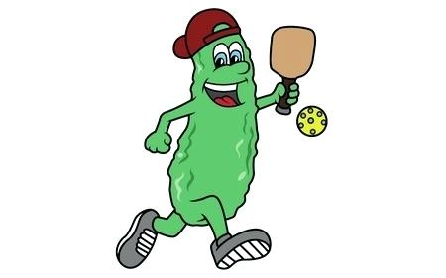

Play Pickleball & get OUT of the kitchen

Cody SHOWDOWN Pickleball’s 2024

SPRING SHAKE & BAKE BATTLE and Potluck

Registration Is Now Open

Ends: 4/8/2024

When: Friday 8:30 a.m. April 12 Men’s and Women’s Doubles Open and Mixed Doubles Open for $$$ Money $$$ Prize 1st & 2nd Places

Saturday April 13 8:30 a.m. Men’s, Women’s and Mixed Doubles, Medals for

1st, 2nd and 3rd places, POTLUCK

Location: Cody Rec Center Indoor Courts (1402 Heart Mountain St., Cody, WY)

Format: Round Robin followed by Single elimination (Note: Rally scoring will be used for Round Robin)

WHO: Recreational (2.5-3.0) Intermediate (3.5-3.75) Advanced (4.0-5.0)

We may cancel or combine skill levels if needed. If you need a partner, we will do our best to find one for you.

Entry Fee: Friday: 1 event: $75.00/player 2 events: $145.00/player

Minimum 6 teams per event for $$$ prize:

6-7 teams for $$$ prizes: 1st place team $300.00, 2nd place team $200.00

8-9 teams for $$$ prize: 1st Place team $400.00, 2nd place team $250.00

10 teams and more for $$$ prize: 1st place team $500.00, 2nd Place team $300.00

Saturday: $50.00/player (1 event) $70.00/player (2 events)

You must register and make payment by 4/9/24 in order to play.

***** If you register and pay to play an Open doubles events on Friday, then no fees will be added to play on Saturday.

Pay by: VENMO (@Peter-Okada) or mail your check along with
the registration form to Peter Okada, 1237 Willow Lane, Cody, WY 82414
You will also need to sign a Waiver on game day.

Potluck: Saturday April 13 - Please bring something to share

Any questions, please contact Peter at 307-250-0457.

REGISTRATION FORM

Events | Skill Level | Partner’s Name
Friday April 12
Men’s Doubles OPEN | $$$$$$$
Women’s Dbl OPEN | $$$$$$$
Mixed Doubles OPEN | $$$$$$$
Saturday April 13 | Circle your level
Women’s Doubles | R I A
Men’s Doubles | R I A
Mixed Doubles | R I A
 |  | Skill Level: Recreational Intermediate Advanced

Friday: Open Doubles $75.00/player (1 event) $145.00/player (2 events)

Saturday: $50.00/player (1 event) $70.00/player (2 events)

Total $:____________________

Name: _____________________________

Rating: ____ https://usapickleball.org/tournaments/tournament-player-ratings/player-skill-rating-definitions/

Email:_______________________________Phone_____________________ CITY___________

There will be door prizes so make sure you put your name in a hat.

